The Problemist 2018-19 Study Tourney Final Award
I received several comments from various composers, although in the end I decided on just a single change in the award. The 6th Prize (Kuzmichev) winner suffered from a self-anticipation. The two versions are given below.

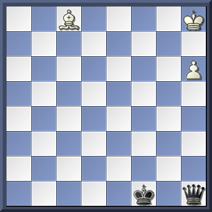

E1267 Vladimir Kuzmichev

1.Bh3+ Kf2 2.h7 Ke3 3.Kg7 Qa1+ 4.Kg8 Qa8+ 5.Kg7 6.Bd7 Qb2+ 7.Kg8 Qg2+ 8.Kf8 Qh2 9.Kg8 Qg3+ 10.Bg4 Qb8+ 11.Bc8 Qb3+ 12.Be6 ½–½

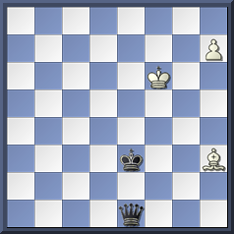
Valdimir Kuzmichev
Polish Chess Federation Tny 2018

1.Kf7 Qa1 2.Kg8 and so on as above.

The first point is that composers should declare known predecessors and if you have composed them yourself, there isn’t really any excuse for not doing so. Judges can’t be expected to see every published study and, at the time of the original award, the new van der Heijden database had not appeared, making it harder to find recent anticipations.
Regarding the studies themselves, the position after White’s 4th move in the award is identical to that after White’s second move in the Polish tourney study. The addition of two extra moves, including a further bishop sacrifice, is a worthwhile improvement, but composers cannot expect to repeatedly gain high awards for incremental improvements to existing studies. The Ukrainian pole-vaulter Sergey Bubka broke world records 35 times, mostly by the smallest possible margin, gaining $40,000 each time, but the same method need not apply in study tourneys! Therefore, the Kuzmichev study loses its 6th Prize and gains instead a Special Commendation in recognition of the fact that it is probably the ultimate form for this idea. A consequence is that the 7th Prize winner (E1224 by Krug and Garcia) is promoted to 6th Prize.

John Nunn

